Covid-19 Reporting System

You work for a health services provider called HeartBeat Inc., and your supervisor, Burt Lancaster, has instructed you to investigate whether or not it is feasible to develop a computer workflow process that would allow the local health authority to report on the number of covid-19 cases, deaths and vaccines on a daily basis. The system should accomplish the following:

1. Download daily updates for all Canadian Provinces for number of: Cases, Deaths, and Vaccinations in csv format from <https://api.opencovid.ca> in json format
2. Identify and merge the new data into a Covid-19 MS SQL Database making sure there aren’t duplicates in the database.
3. Automate the database update process using the MSSQL Database scheduler by running an MS SSIS package on a daily basis
4. Provide the ability to view and print an MS SSRS Report showing how many cases, deaths and vaccinations administered, all by 100,000 population
5. Provide the ability to view a Map (geospatial polygons) of the highest to lowest concentrations of cases, deaths and vaccinations in MS PowerBI

ICE 4 –Automate API Data Import (15 pts)

Using the SSIS Package you created in ICE 3, please do the following:

1. Create a Batch (.bat) file that runs your SSIS Package
2. Setup a Windows Schedule to execute the batch file on a daily routine

Please upload screen captures (png format) of:

1. Your SSIS Package running successfully in MS Dos

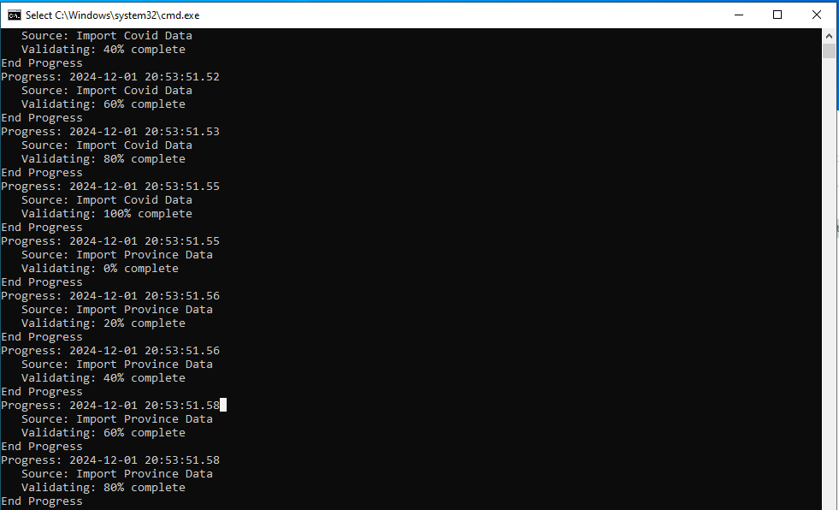

1. Your Package successfully running in the Windows Task Scheduler:

Hint:

You will need to include the following command in the batch file to run your package:

"C:\Program Files (x86)\Microsoft SQL Server\150\DTS\Binn\DTExec.exe" /f "C:\Users\Student\Desktop\Code\Covid19\Package.dtsx"